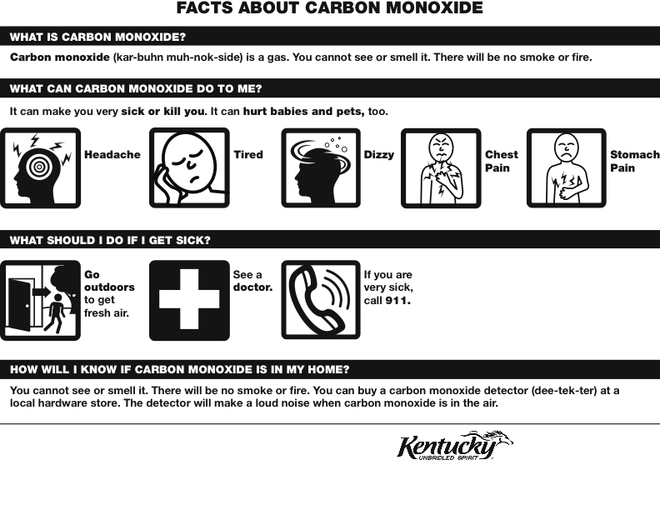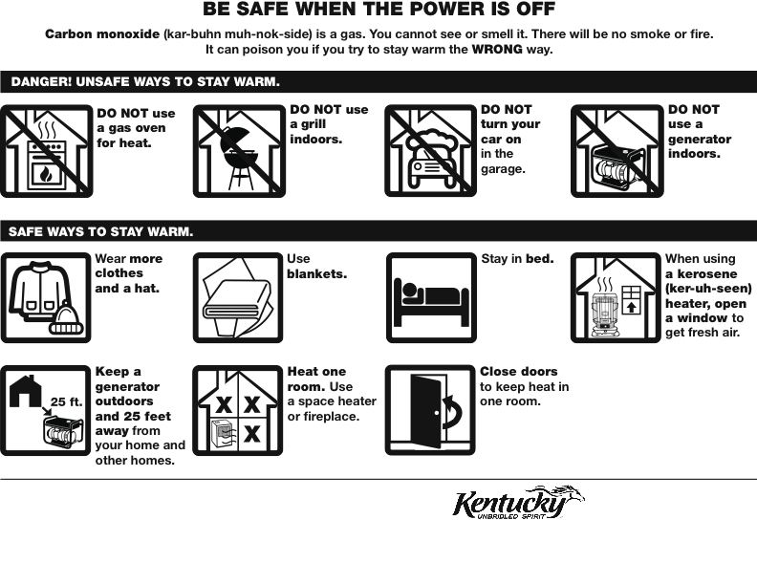

**Kentucky Cabinet for Health and Family Services, Frankfort, Ky.**

**502-564-7243**

**http://chfs.ky.gov/preparedness**

**Kentucky Regional Poison Center**

**Louisville, Ky.**

**Emergency: 1-800-222-1222**

**http://www.krpc.com**

**For more information**

***[INSERT Local Health Department Name]***

***[INSERT LHD phone number]***

**Kentucky Regional Poison Center**

**Louisville, Ky.**

**Emergency: 1-800-222-1222**

**http://www.krpc.com**

**Kentucky Cabinet for Health and Family Services, Frankfort, Ky.**

**502-564-7243**

**http://chfs.ky.gov/preparedness**

**For more information**

***[INSERT Local Health Department Name]***

***[INSERT LHD phone number]***